Pre – model exam

Name : c.akhil

## Reg no : 192110244

# Q1 member function

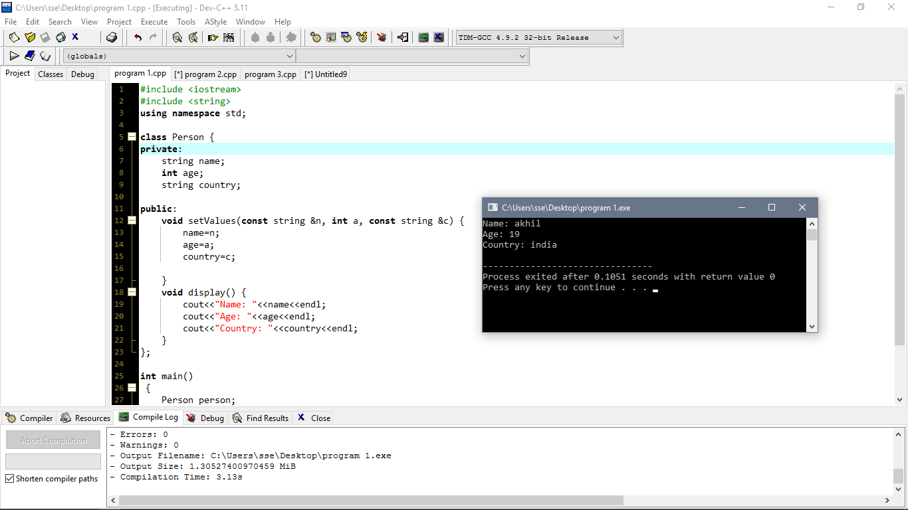

Q2 area of rectangle

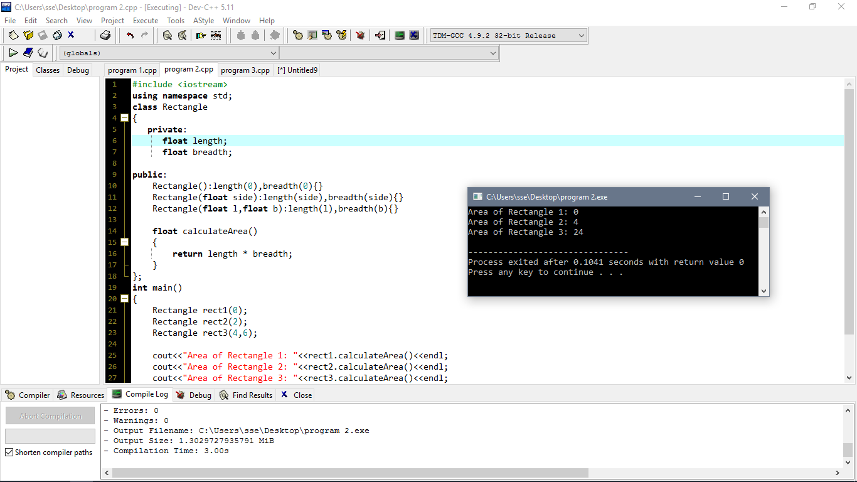

Q3 pattren

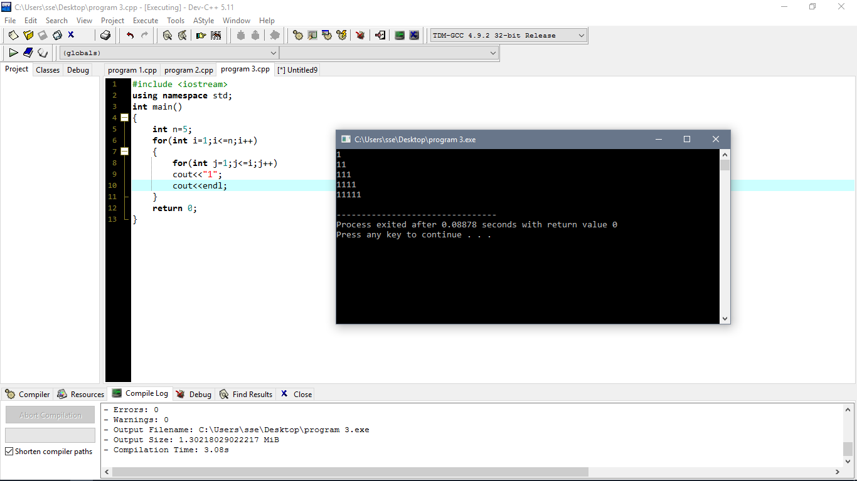

Q4 student data

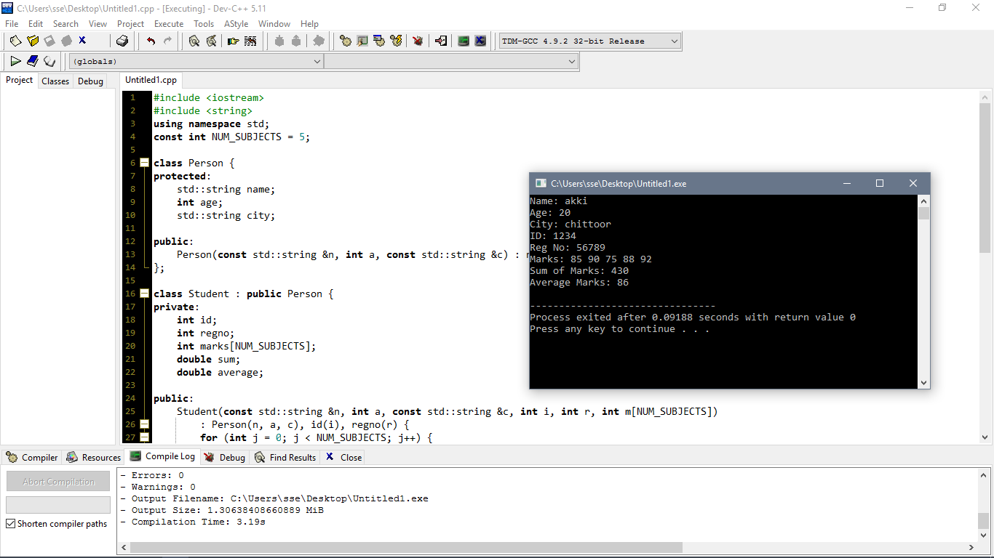

Q5 VOWELS

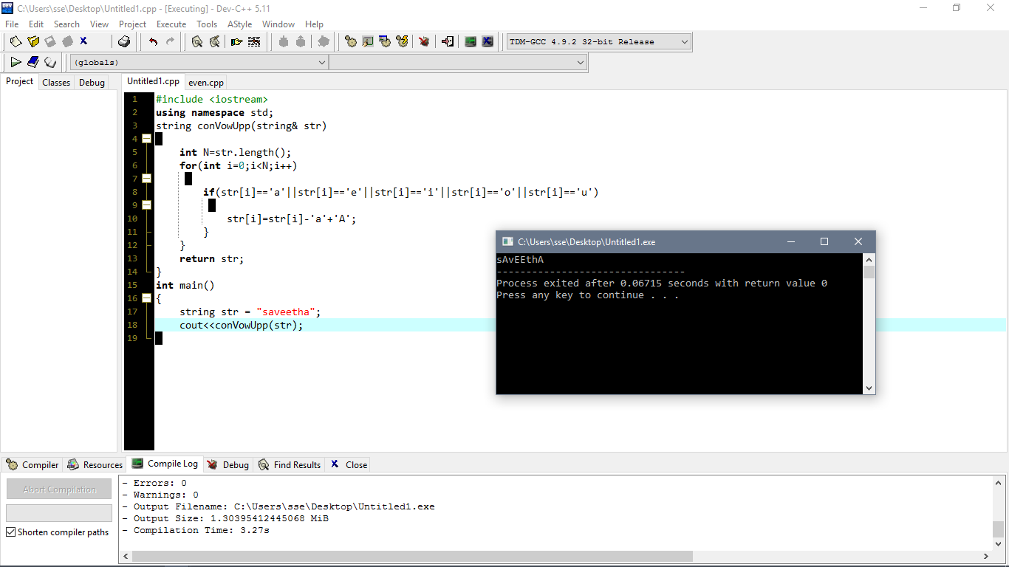

Q6 PRINT EVEN NUMBERS IN AN ARRAY

